Memorandum

Purpose
The purpose of this memo is to provide a summary of the analysis of the activities to be conducted for the Draft Proposal of the SharePoint Information Portal (SIP) Work Package One (WP1). This bid has four phases identified at Phase I,II,III, IV and subsequent support as Phase V (not included in this memo). Vendor is looking for Analysis, Summary, Concept of Operations , Schedule and Labor Category analysis for this project. An excel spreadsheet and draft project schedule is to be provided as an adjunct to this memo to present the details of the analysis.

Table of Contents
1 Purpose 1
1.1 Table of Contents 2
1.2 List of Figures 3
1.3 List of Tables 3
2 SIP WP1 Overview 4
2.1 SIP WP1 Burn Rate(s) 4
2.2 Preliminary Overview of WP1 Phases I,II,III,IV Activities 4
3 WP1 Schedule 5
3.1 WP1 Phase I Schedule – 26 Weeks (4-6 Persons) 6
3.1.1 Setup Project Resources 7
3.1.2 SIP Project Requirements Management 7
3.1.3 Design SharePoint Software Architecture 8
3.1.4 SharePoint Systems Engineering 8
3.1.5 WP1 Phase 1 – Requirement Transfer/ Build/Test SharePoint 2010/13 Prototype 8
3.2 WP1 Phase II Schedule – 8 Weeks (4-6 Persons) 12
3.2.1 WP2 – Phase II Support Customer Pilot Implementation located at Vendor Testbed 12
3.3 WP1 Phase III Schedule – 4 Weeks (4-6 Persons) 13
3.3.1 WP1 – Phase III Coming Out Support Host Nation Buy-In 13
3.4 WP1 Phase IV Schedule – 7 Weeks (Up to 4 Additional Persons – Total 10) 14
3.4.1 WP1-Phase IV Deployment to Vendor Host Remote Sites and Decommission Legacy System. 14
3.5 Vendor PM for Work Package 1 18
4 Job Descriptions 20
4.1 Program Manager/Project Team Leader (1 Person) 20
4.2 System Engineer(s) (2-3 Persons) 20
4.3 SharePoint Software Engineers/Architecture (2-3 Persons) 20
4.4 SharePoint Network Administrator (1 Person?) 20
4.5 Training and Support Engineer (1 Person?) 20
5 SIP SharePoint Preliminary Concept of Operations 22
5.1 SIP SharePoint2010/13 Cloud Network 22
5.2 Regional Node Hardware and Software Architecture ( 3 Tier Solution) 23
5.3 SIP Interfacing Requirements 24
5.3.1 SIP to DHS Interface 24
5.3.2 SIP to WISE Interfaces 24
5.3.3 SIP Task Tracking System (TTS) 24
5.3.4 SIP Additional Interfaces 24
5.4 SIP User Interface 24
5.4.1 Roles Based User Authentication 24
5.4.2 Establishment of Community of Interest (COI) Needlines. 25
5.4.3 SIP SharePoint Farm Services 25
6 Reference Guidelines for SIP Project Management 26
6.1 Concept and Requirements Plans. 26
6.1.1 Operational Concept Description(OCD) 26
6.1.2 System/Subsystem Specification (SSS) 26
6.1.3 Software Requirements Specification (SRS) 26
6.1.4 Interface Requirements Specification (IRS) 26
6.2 Planning Specifications 26
6.2.1 Software Development Plan (SDP) 26
6.2.2 Software Installation Plan (SIP) 26
6.2.3 Software Transition Plan (STrP) 26
6.3 Design Specifications 26
6.3.1 System/Subsystem Design Description (SSDD) 26
6.3.2 Software Design Description (SDD) 26
6.3.3 Database Design Description (DBDD) 27
6.3.4 Interface Design Description (IDD) 27
6.4 Qualification Plans and Testing 27
6.4.1 Software Test Plan (STP) 27
6.4.2 Software Test Description (STP) 27
6.4.3 Software Test Report (STR) 27
6.5 Software Products 27
6.5.1 Software Products Specification (SPS) 27
6.5.2 Software Version Description (SVD) 27
7 Assumptions 28
8 References 28
9 Acronyms 31

List of Figures
Figure 1 SIP RFP WP1 Schedule Phases I,II,III,IV 5
Figure 2 SIP WP1 Work Package Phases I,II,III,IV 6
Figure 3 WP1 Phase I Tasking (TBD) 11
Figure 4 WP1 Phase I Tasking Cont'd (TBD) 11
Figure 5 WP1 Phase I Tasking Cont'd (TBD) 11
Figure 6 WP1 Phase II Tasking (TBD) 12
Figure 7 WP1 Phase III Tasking (TBD) 13
Figure 8 WP1 Phase IV Tasking (TBD) 17
Figure 9 Vendor Program Management of Bidder during WP1 Phases I,II,III,IV (TBD) 18
Figure 10 SIP Cloud Network via Vendor Regional Site Web Portals 22
Figure 11 SIP WP1 SharePoint Node 3 Tier Solution (No Storage Area Network Shown) 23
Figure 12 COI Needlines Communications (Virtual Private Network) (TBD) 25

List of Tables
Table 1 SIP WP1 Phase I RFP Requirements 9
Table 2 WP1 Phase I RFP Tasking Schedule 10
Table 3 WP1 Phase II RFP Requirements 12
Table 4 WP1 Phase II RFP Tasking Schedule 12
Table 5 WP1 Phase III RFP Requirements 13
Table 6 WP1 Phase III RFP Tasking Schedule 13
Table 7 WP1 Phase IV RFP Requirements 14
Table 8 WP1 Phase IV RFP Schedule (Note Phase III Task allows Schedule Adjustment) 16
Table 9 WP1 Vendor PM Tasking Schedule (TBD) 19

SIP WP1 Overview
The schedule for WP1 begins with the award of the contract (CA1) and Final System Acceptance (FSA). FSA is schedule to complete thirteen months after CA1. The budget for WP1 is to be the Lowest Compliant Bid (LCB). Vendor has provided a draft proposal for review. In the bid, the parts that apply to WP1 are identified as the four phase components and Vendor Program Management Support Activities to be provided by PMIC (Independent Review, Verification and Testing Activities). The budget for WP1 is summarized here:
- PMIC Program Management WP1 Phases I,II,III,IV $797,234
- WP1- Phase I - Development of the SharePoint 2010/13 Prototype for Vendor Information Portal €580,650/$793,748 (CA1)
- WP1 – Phase II – Migrate Prototype to Vendor Testbed as the Pilot Platform $290,760
- WP1 – Phase III – Coming Out conduct Site Surveys to the Regions II,III and other Vendor sites $157,888
- WP1 – Phase IV – Build Out to SharePoint 2010/13 System into Regions II,III and Vendor sites $1,705,469. (FSA)

SIP WP1 Burn Rate(s)
For these details one can see the funds for the Vendor project available to bidder the totals for Phases I,II,III,IV. The total amount of funds for the bid is $2,947,865. This excludes the funds to be used by PMIC for the Program Management Efforts in WP1.

Based on the analysis using theVendor Number of ManDays at 246 per year or for 13 months 266 Mandays in 13 months (CA1 to FSA).

To compute the upper limit of the average project total burn rate per day $2,947.865/266 = $11,082 Per Day.
- Upper Limit Average Project Daily Burn Rate $11,082
- Upper Limit Average Project Weekly Burn Rate $55,411
- Upper Limit Average Project Monthly Burn Rate $221,643

In the draft bid schedule B they show the rates at the upper limit at $1980/Manday or $247/Hr. Using the upper limit of the Labor Rates one can determine the maximum number of persons that can be allocated to the project. $11,082/1980 = 5.6 Persons. This provides Bidder an upper limit guideline to the amount of labor resources that can be applied to the project. Note here that this estimate uses the highest labor rate not the average labor rate. The lower limit of the labor rate is $1230ManDay. Based on the Lower Limit Labor Rate: $1230 = 8.66 Persons.

Hence base on this analysis in order to bid the project number of people on the project should be in the range of 5 to 8 people as the average this 6.5 Person(s). This financial analysis indicates the average staffing level for the lifecycle of the project should not exceed 6 persons.

Base on the details of Schedule B a preliminary analysis indicates the project should have the following for WP1 Phases I, II, III,IV.
- Program Manager (1)
- System Engineers (2)
- SharePoint Software Engineers (2)

Preliminary Overview of WP1 Phases I,II,III,IV Activities
The Schedule B Table in the proposal identify the resources and allocated schedule activities in the WP1 Phases. To support the project. Will be responsible in Phase I to develop the prototype SharePoint 2010/13 Solution. In Phase II the Prototype will become the Pilot SharePoint System to be evaluated by Vendor at the site Testbed.. (Both in Phases I and II extensive Systems Engineering reporting is required) as identified in the schedule baselines. As Bidder progresses in the SharePoint effort, Vendors’s program management (PM) will be responsible for Program Management efforts. PM will review Vendor SharePoint Design (Proof of Concept), Supporting Documents, Configuration Management and Program Management Activities.
The Bidder SharePoint Solution is to support the Vendor ISAF Dublin Core (SharePoint 2010/2013) Farm Solution. As a starting Point in Phase I. Bidder is to receive and review the Vendor Requirements Documents, Obtain the Work Package Two (WP2) SharePoint Corporate Templates. In Phase II Vendor is to perform a Site Survey of the Hardware and Software Environment for the Vendor Pilot System only.
In WP1 Phase III, this is identified as the coming out activities. Here Bidder will support the Vendor Efforts to obtain buy-in from the other two Vendor Host Regions II,III and the additional Host sites.
The Vendor SIP will reside in the three regions (I,II, III) in the physical hardware and software configurations available at these sites. The site survey will identify the configuration requirements needed.

WP1 Schedule
This section presents the draft schedule for WP1. Based on the details here the timeline is 266 Vendor ManDays. The Mandays allocated to each Phase of WP1 is as follows:
- Phase I – 543 ManDays/ 48.48% of Total Mandays (Length 130 Mandays = 26 Weeks – 4 Persons)
- Phase II – 172 ManDays/ 15% of Total Mandays (Length 40 Man Days = 8 Weeks – 4 Persons)
- Phase III – 85 ManDays/7.6% of Total Mandays (Length 20 Man Days = 4 Weeks – 4.25 Persons)
- Phase IV – 370 ManDays/33% of Total Mandays (36 ManDays = 7 Weeks- 10 Persons)
The total is 1170 ManDays/266 Mandays (CA1 to FSA) = 4.4 Persons over the Project LifeCycle.

This analysis is based on timeline between CA1 to FSA.. A reconciliation between the Schedule B and this is the next step. This analysis shows the project in Phase IV deviates from the average. Hence smoothing project labor resources in Phase IV is required.

Figure 1 SIP RFP WP1 Schedule Phases I,II,III,IV

Using the information the project parameters should be adjusted:
- Program Manager/Systems Engineer (1)
- System Engineer (2)
- SharePoint Software Engineers (2-3)

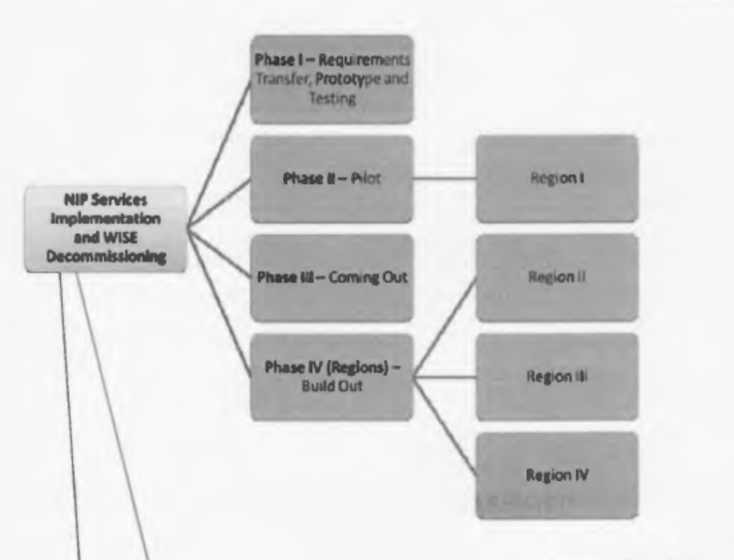
Figure 2 SIP WP1 Work Package Phases I,II,III,IV

WP1 Phase I Schedule – 26 Weeks (4-6 Persons)
In WP1 Phase I Vendor will establish the core team to work on the SIP project. The team will consist of a Program Manager responsible for schedule, budget and deadlines, Two System Engineers to interface with the customer, software team and management. The Software Team will be at least two SharePoint Software Engineers with skills in SharePoint Architecture Design on Web Portal Networks.
This effort entails coordination with the Vendor Program Management Team(s). To obtain the Detailed Requirements, Obtain the SharePoint Corporate Templates from WP2, Setup Local SharePoint Development and System Engineer Platforms, Setup a Configuration Management System, Design and Implement a SharePoint Prototype Architecture at the Bidder Site. Develop Baseline Software Builds in the Configuration Management System. System Engineering will Interface with the Customer identify and build the Deliverable Documents within schedule. System Engineering will Design and Implement the Software Testing Plans. A problem resolution management system will be used to identify technical issues and task Software Team to correct issues.
In the initial part of award WP1 Phase I, Bidder will need to establish the resources and management to be utilized through the life cycle. Presented here is the identification of some of resources to be implemented upon award of the contract.

Setup Project Resources
  - Appoint a Project Leader/Program Mgr
    - Review and Revise Proposal Schedule(s) for internal efforts for WP1
    - Adjust Schedule to dates identified by PM for Phase I deliverables
    - Establish Tasking for Facilities Resources
    - Establish Tasking for System Engineering
    - Establish Tasking for SharePoint Software Development of Prototype
  - Allocation of Budget
    - Establish Cost Accounting
  - Allocation of Facilities Computer Lab, SharePoint Servers to comply with the SIP configurations. Setup Portal Interfaces to be used for internal testing. (Need to platforms one for Development a second for internal verification testing).
  - Allocate Labor Resources (Systems Engineering and SharePoint Architect/Developers)
  - Setup Requirements Management System(RMS) ( Used for allocation of SIP requirements to HW, SW, Test, Interface(s) and Project Schedule Deliverables
  - Setup Configuration Management and Build System (CMS). (used to obtain a baseline version of a prototype software build)
  - Setup Problem/Issues Tracking/Reporting System (PTR) used in project management to identify issues and resolutions. (Suggest Weekly internal reviews and resolutions).
  - Setup SIP,DHS,WISE Portal Interfaces available for Prototype Testing at Bidder site.

SIP Project Requirements Management
  - Obtain SIP Requirements and place into RMS, Allocate SIP Requirements to categories: (Hardware, Software, Interface, Test, Document, Project Deliverables/Schedule).
  - Update Software Design Specification to show traceability back to NIP Requirements
  - Assign Software Requirements to SharePoint Software Development
  - Assign Testing Requirements to Parties responsible to provide test plans/procedures.
  - Subsequent updates to RMS with traceability of Software Detailed Requirements to SIP Requirements
  - Subsequent updates to RMS with traceability of Test Plans/Procedures to SIP Requirements (Independent of Software Requirements).

Design SharePoint Software Architecture
  - Incorporate SIP Software Requirements
  - Develop Software Requirements Document (SRS)
    - Include SIP Requirements Trace
    - Identify Software Builds via allocation of baseline
    - Internal Review
  - Develop SDD Document
    - Internal Review
  - Develop Software Build per Functional Allocation Baseline(s)
    - Build SharePoint Baselines install into configuration management
    - Place Software Baseline and related technology into Configuration System

SharePoint Systems Engineering
  - Design Testing Plans per Baseline Allocation(s)
  - For each Baseline Iteration Extract from Configuration Management Software Baseline
    - Execute Test Procedures and report results
      - For Issue Identified update Problem Tracking System
    - Report Testing Results

WP1 Phase 1 – Requirement Transfer/ Build/Test SharePoint 2010/13 Prototype
4.4.2.2.1.1 | Receive, analyze, review all information in WP2 including Corporate Templates
4.4.2.2.1.2 | Perform Joint Technical Reviews
4.4.2.2.1.3 | Setup Environment at Contractors’ Location
4.4.2.2.1.4 | Participate in User Working Group Meetings
4.4.2.2.1.5 | Analyze Security Requirements, Review with Vendor Host Sites to obtain accreditation
4.4.2.2.1.6 | Design, document review all SIP Services
4.4.2.2.1.7 | Develop, test and document all NIP services
4.4.2.2.1.8 | Perform Factory Acceptance Test (FAT) with Host Nation and Support Authority
4.4.2.2.1.9 | Implement system in the PM Test Bed Site
4.4.2.2.1.10 | Perform System Integration Test and User Acceptance Test
4.4.2.2.1.11 | Perform System Integration Test
4.4.2.2.1.12 | Perform IT&V Test
4.4.2.2.1.13 | Review, update and document Products Baseline for life cycle.
Table 1 SIP WP1 Phase I RFP Requirements

SubTask(s) | Person(s) | ManDays-Person | Total Mandays
Requirements Transfer | 2 | 12 | 24
Architecture, Proof of Concept | 3 | 60 | 180
Factory Acceptance Test | 2 | 3 | 6
SRS Review | 2 | 6 | 12
Prototype PM Test Bed | 3 | 15 | 45
User Acceptance Test1 | 3 | 3 | 9
User Requirements Review | 2 | 6 | 12
User Acceptance Test2 | 3 | 3 | 9
SIP Prototype | 3 | 6 | 18
SIP Product Baseline | 2 | 22 | 44
Security Requirement Analysis | 1 | 5 | 5
IT&V | 2 | 12 | 24
AMN CBT Alignment Train & Docs | 2 | 30 | 60
System InterOp Profiles Defn & Dev | 2 | 25 | 50
DHS Service Interface | 2 | 10 | 20
FSA | 2 | 2 | 4
Travel | 2 | 10.5 | 21
WP1 Phase1 Totals |  | 230.5 | 543
Table 2 WP1 Phase I RFP Tasking Schedule

Figure 3 WP1 Phase I Tasking (TBD)

Figure 4 WP1 Phase I Tasking Cont'd (TBD)

Figure 5 WP1 Phase I Tasking Cont'd (TBD)

WP1 Phase II Schedule – 8 Weeks (4-6 Persons)

WP2 – Phase II Support Customer Pilot Implementation located at Vendor Testbed
In WP1 Phase II. The team will provided on going technical support to Deliverable Pilot Version obtained from the verified allocated baseline approved by Bidder System Engineering Team. The PM will assist in the review and approval of the system baseline build deliver to the Vendor Test Evaluation Team(s).
4.4.2.3.1.1 | Participate in pre-deployment meetings
4.4.2.3.1.2 | Collaborate to a second Pilot Site Survey
4.4.2.3.1.3 | Deploy, activate and test Pilot Site
4.4.2.3.1.4 | Perform Site Acceptance Test
4.4.2.3.1.5 | Provide Training to Users, Functional and System Administration
4.4.2.3.1.6 | Support Legacy System Migration to SIP (Web Contents, DHS documents transfer)
Table 3 WP1 Phase II RFP Requirements

SubTask(s) | Person(s) | ManDays-Person | Total Mandays
Site Survey Pilot | 2 | 6 | 12
Pilot Implementation | 3 | 22 | 66
Initial Training | 1 | 12 | 12
Regional Mirrors Implement | 2 | 15 | 30
System Integration Test | 1 | 6 | 6
Site Acceptance Test | 1 | 3 | 3
Migration to SIP & Integration | 1 | 17 | 17
Migration to DHS & Integration | 1 | 12 | 12
Legacy System Decommission Support | 1 | 3 | 3
Travel | 2 | 5.5 | 11
WP1 Phase2 Totals |  | 101.5 | 172
Table 4 WP1 Phase II RFP Tasking Schedule

Figure 6 WP1 Phase II Tasking (TBD)

WP1 Phase III Schedule – 4 Weeks (4-6 Persons)

WP1 – Phase III Coming Out Support Host Nation Buy-In
Up to this point, the team was involved with building the Prototype and Pilot Version of the SIP Share Point System located at the Vendor Test bed and subsequently installed onto the Region I system. In this phase the effort is to support deployment of the SharePoint System onto the other nodes and conduct the site surveys for the remaining SharePoint Sites. Here also the Bidder Program Management team will adjust schedule for tasking of WP1 Phase IV.
4.4.2.3.2.1 | Support Marketing and Communication Campaign to achieve buy-in by the Vendor remote user user community
4.4.2.4.1.1 | Conduct Site Surveys, inform user community of SIP values and Pilot experience
4.4.2.4.1.2 | Refine Implementation Schedule
Table 5 WP1 Phase III RFP Requirements

SubTask(s) | Person(s) | ManDays-Person | Total Mandays
Site Survey Region II | 2 | 6 | 12
Site Survey Region III | 2 | 6 | 12
Vendor Mtg | 1 | 6 | 6
Legacy Survey Site 1 | 1 | 3 | 3
Legacy Survey Site 2 | 1 | 3 | 3
Legacy Survey Site 3 | 1 | 3 | 3
Legacy Survey Site 4 | 1 | 3 | 3
WISE Survey Site 5 | 1 | 3 | 3
WISE Survey Site 6 | 1 | 3 | 3
WISE Survey Site 7 | 1 | 3 | 3
WISE Survey Site 8 | 1 | 3 | 3
WISE Survey Site 9 | 1 | 3 | 3
WISE Survey Site 10 | 1 | 3 | 3
Implement Prep | 2 | 5 | 10
Travel | 2 | 7.5 | 15
WP1 Phase3 Totals |  | 60.5 | 85
Table 6 WP1 Phase III RFP Tasking Schedule

Figure 7 WP1 Phase III Tasking (TBD)

WP1 Phase IV Schedule – 7 Weeks (Up to 4 Additional Persons – Total 10)
In WP1 Phase IV Bidder supports the deployment of the SIP System to the other Vendor Regional sites and Host Web Sites. The SIP RFP calls out to complete this effort in 7 weeks. Based on this schedule the Bidder Team would need to expand to an additional 4 people. However, in Phase III one of the task indentified is to refine the implementation schedule. This will enable Bidder to make adjustments that can potentially prevent additional staffing of the team hence reducing the overall project management of labor resources.

WP1-Phase IV Deployment to Vendor Host Remote Sites and Decommission Legacy System.
4.4.2.5.1.1 | Participate in pre-deployment meetings at each site
4.4.2.5.1.2 | Deploy, activate and test the Pilot Site
4.4.2.5.1.3 | Perform Site Acceptance Test
4.4.2.5.1.4 | Provide Training to Users, Functional and System Administration
4.4.2.5.1.5 | Support Legacy Migration to SIP (Web Contents, DHS documents xfer)
4.4.2.5.2 | Support Vendor remote sites user community with initial Legacy system data migration and decommissioning.
4.4.2.5.3 | To support and simplify transition to SIP,Leverage Current Legacy business processes per content management and user interfaces. Use as initial starting point for documentation and incorporation into SIP's Vendor’s PM Goverance material
4.4.2.6 | For Migration to SIP, LCB shall develop SIP/DHS interface to leverage SharePoint 2010/2013 web services to call the DHS services directly from SIP interfaces
Table 7 WP1 Phase IV RFP Requirements

SubTask(s) | Person(s) | ManDays-Person | Total Mandays
WP1 Phase4-Build Out Decommission Legacy & Support Regions of Selected Vendor sites
Region II Implement | 3 | 17 | 51
Initial Training | 1 | 12 | 12
Regional Mirrors Implement | 2 | 10 | 20
System Integration Test | 1 | 6 | 6
Site Acceptance Test | 1 | 3 | 3
Migration to NIP and Integration | 1 | 17 | 17
Migration to DHS and Integration | 1 | 12 | 12
Development Effort | 2 | 5 | 10
Legacy Decommission Support | 1 | 3 | 3
Travel | 1 | 6 | 6
Region III Implement | 3 | 17 | 51
Initial Training | 1 | 12 | 12
Regional Mirrors Implement | 2 | 10 | 20
System Integration Test | 1 | 6 | 6
Site Acceptance Test | 1 | 3 | 3
Migration to SIP and Integration | 1 | 17 | 17
Migration to DHS and Integration | 1 | 12 | 12
Development Effort | 2 | 5 | 10
Legacy System Decommission Support | 1 | 3 | 3
Travel | 1 | 6 | 6
Command Implementation | 1 | 17 | 17
Migration to SIP and Integration | 1 | 17 | 17
Migration to DHS and Integration | 1 | 12 | 12
Legacy System Decommission Support | 1 | 3 | 3
Deployment Effort | 2 | 5 | 10
Site Acceptance Test | 1 | 3 | 3
Initial Training | 1 | 12 | 12
Travel | 2 | 3.5 | 7
Site 2 | 1 | 1 | 1
Site 3 | 1 | 1 | 1
Site 4 | 1 | 1 | 1
Site 5 | 1 | 1 | 1
Site 6 | 1 | 1 | 1
Site 7 | 1 | 1 | 1
Site 8 | 1 | 1 | 1
Site 9 | 1 | 1 | 1
Site 10 | 1 | 1 | 1
WP1 Phase4 Totals |  | 263.5 | 370
Table 8 WP1 Phase IV RFP Schedule (Note Phase III Task allows Schedule Adjustment)

Figure 8 WP1 Phase IV Tasking (TBD)

Vendor PM for Work Package 1
During the efforts of WP1 Phases I,II,III,IV, Vendor’s Program Management will be interfacing with Bidder to monitor progress. The Draft RFP Identifies these activities as follows.

Figure 9 Vendor Program Management of Bidder during WP1 Phases I,II,III,IV (TBD)

Table 9 WP1 Vendor PM Tasking Schedule (TBD)

Job Descriptions
The WP1 project requires Program Management, Systems Engineering, Software Development Professionals for the primary efforts. Additional skills needed to develop Computer Based Training and Field Service Support with the WP1 Phase III Site Surveys.

Program Manager/Project Team Leader (1 Person)
A Program Manager to oversee the successful management and completion of a SharePoint Program for a Vendor Multi-National Customer. Tasks involve review and management of budgets and schedules. Interface with the customer meetings and the internal teams, management and allocation of resources (labor, budget, schedule, Hardware/Software Computing Systems). Provide customers and upper management status and progress reporting.

System Engineer(s) (2-3 Persons)
Senior System Engineers, self starter, able to interface with a Vendor Multi-National Customer and travel to sites. Expertise in System Engineering Support of Software Development projects. Understanding of SharePoint 2010/13 Projects. Able to perform Requirements Analysis/Management/Traceability. Able to develop Acceptance Tests. Work with SharePoint Software Team via Configuration Management System to build allocated baseline software system. Able to meet tight deadlines for Customer Deliverables, Good Interpersonal Skills, Solid understanding of Data Communications Systems, Network Provisioning Systems/Services. Able to review SharePoint Software Architecture Design to properly address customer system requirement specifications. In addition able to Administer and Manage a Set of SharePoint Sever(s) (FAST Server, Front End Processors, Back End SQL Server Database, Application and Business Intelligence SharePoint Servers, Management of Farm Servers across a local and remote set of SharePoint backend processors).
At least one of the Systems Engineers needs to have a technical background in being able to support the Security Accreditation Engineering

SharePoint Software Engineers/Architecture (2-3 Persons)
Experience in Software Development within the Microsoft Sharepoint 2010/2013 platforms. (Farm Services, VS2010/2013, C#, SQL Server). Understanding of Web Portal Communications interfaces and Network Provisioning. Experience in using and incorporation of Sharepoint Customer Templates and Frameworks into Design of SharePoint Web Sites. Able to work with Systems Engineering to manage configuration management systems to build baseline software functionality. Able to work on a Multi-National project and interface with management of customer. Work with Systems Engineering design a SharePoint Architecture based on Customer Systems Requirements, Schedule and Budget. Able to Present to Management and Customers Sharepoint Design. Able support System Testing environments. In addition able to Administer and Manage a Set of SharePoint Sever(s) (FAST Server, Front End Processors, Back End SQL Server Database, Application and Business Intelligence SharePoint Servers, Management of Farm Servers across a local and remote set of SharePoint backend processors)

SharePoint Network Administrator (1 Person?)
In the case of not having labor identified above with SharePoint Network Administration Skills and additional person with SharePoint Network Administration skills may be needed.
Able to Administer and Manage a Set of SharePoint Sever(s) (FAST Server, Front End Processors, Back End SQL Server Database, Application and Business Intelligence SharePoint Servers, Management of Farm Servers across a local and remote set of SharePoint backend processors). Able to provide technical support to the team with respect to deployment strategy of the Bidder’s local prototype and support the Multi-National On Site Customer support requirements.

Training and Support Engineer (1 Person?)
The activities of WP1 identify for Bidder to provide Customer Training and support. If the System Engineering team is able to support this effort then these tasks can be assigned to the System Engineering Team. If this is not available an additional Labor Resource to support local and on-site at Multi-National sites customer training needs will be required.

SIP SharePoint Preliminary Concept of Operations
This section presents the preliminary proof of concepts for the NIP Project.

SIP SharePoint2010/13 Cloud Network
The SIP Cloud Network consists of three Physical SharePoint Nodes one located at each Regional (I,II,III) Site. Within these nodes is a set of Vendor sites setup in SharePoint Sites installed on the corresponding Node to which the Vendor remote site are assigned. The SIP Communications background is a set of Communications Services allocated via the SIP Service Provisioning Authority(SPA). The allocation of the SIP Communications Backbone Network via the SPA will determine how efficient the overall SIP Network responds to the user community Information Services Requirements.
Vendor Internet Communication Backbone (SPA Management)

Region I SharePoint Node with Vendor Remote Sites

Region II
SharePoint Node
with Vendor Remote Sites

Region III SharePoint Node
with Vendor Remote Sites

SIP Network
Web Portal
Interfaces

Figure 10 SIP Cloud Network via Vendor Regional Site Web Portals

Regional Node Hardware and Software Architecture ( 3 Tier Solution)

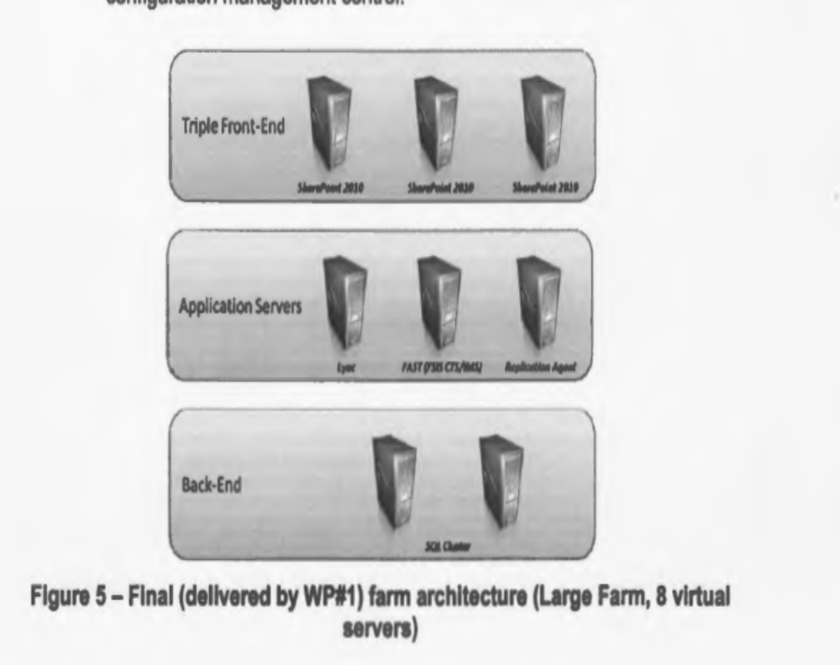
Figure 11 SIP WP1 SharePoint Node 3 Tier Solution (No Storage Area Network Shown)

Each of the Nodes in the Cloud Network contains a set of SharePoint Servers configured in three tiers as follows:
- Tier 1 (Front End Processors) - Three Windows Servers with 2008/R2 or current version with SharePoint 2010/13 Server Software (or current version) Installed as Front End Processors
- Tier 3 (Back End Processors) - Two Windows Server 2008/R2 or current version and Current Microsoft SQL Server installed. They are configured to mirror the other (Replication Databases Write to both/Read from Master Server) . Interfaced to the SAN
- Tier 2 (Application Servers) – This middle tier contains a set of SharePoint Servers two nodes are configured as FAST Indexing servers.
  - Redundant FAST Server Nodes - Two Windows Server 2008/R2 or current version configured as SharePoint Servers with FAST Server Indexing installed configured redundantly on two Nodes. The WP1 Requirements for this is identified as follows:
    - A FAST (Microsoft SharePoint Server), is part of AMN IOC. This is two main nodes that replicate and exchange global index data. Also contains 4 minor nodes that crawl local content. This is able to index any data source and consolidate results in a single page.
    - Note: The SIP Bid calls out to use the “Dublin Core” and to utilize the ISAF AMN lessons learned. On important point is the usage of a Microsoft FAST Search Engine using Extended Markup Language (XML) Base on the Dublin Core XML Tagging. This tagging of NIP resources within the indexing used by the FAST Search engine is known as a Taxonomy (Dublin Core Metadata Initiative – DCMI). http://dublincore.org/ The proposal calls out to define how within the SharePoint System in the Work Package One (WP1) Phase 1 prototype Design (Proof of Concept) NIP will support FAST Search Engine Indexing of NIP Data based on Dublin Core MetaData Taxonomy in XML.

  - Microsoft Lync Communications Server – This provide enterprise real-time communications for enterprise instant messaging, VOIP, Web/Video Conferencing via a Gateway or SIP truck.
  - Microsoft Application Agent – This server provides network administration of SharePoint 2010/13 application to monitor performance using Microsoft Monitoring Agent
  - Microsoft SharePoint Farm Services – Within the Application Tier Servers SharePoint Farm services can reside to support Business Intelligence (BI) customized applications.

SIP Interfacing Requirements

SIP to DHS Interface
The SIP proposal identifies the requirement for the NIP Cloud to interface to the Work Package Two (WP2) Document Handling System (DHS). The specifications of this interface are TBD.

SIP to WISE Interfaces
The SIP Proposal identifies requirements to interface to the Legacy System Portal Interfaces. The detailed specifications for the interface are TBD.

SIP Task Tracking System (TTS)
The Bid identifies the requirement to interface to the Task Tracking System. The specifications are TBD.

SIP Additional Interfaces
Additional Interfaces to be supported are TBD.

SIP User Interface

Roles Based User Authentication
This section presents some of the details from the viewpoint of interfacing with the SIP Cloud Based Web Services. All users are authenticated upon login. The user is able to access information within NIP that is allowable by the access permissions of his Role Base User Login Profile. SIP provides discretionary access controls (DAC) based on the Bell-Lapadula Model of secure access with respect to the Subject(s) and Object(s) within the NIP Network. This model means the user can not read information with access attributes not allowable by the user Role(s) Profile. In addition the user is not able declassify information to a lower security level (No Read Up/No Write Down). SharePoint is not a Multi-Level Security system (MLS) but does provide Role(s) Based Access controls (RBAC). When the user attempts to access information outside of his local Vendor Site, SIP will provide a seamless authentication via Active Directory (AD) data encryption via an assigned user token (encryption key) that is used by the AD system to allow/deny information access.

Note: This are only DAC security controls. In addition, the SIP system operating at NS needs to provide Mandatory access control (MAC). This is achieved by the utilization of Hardware Based Encryption (eg. In-Line Network Encryptors (INE)). The management of the INE devices includes using a Public Key Infrastructure (PKI) that manages Hardware Based Data Encryption across the SIP Portals thru the Network Backbone to the end point regional nodes.

Establishment of Community of Interest (COI) Needlines.
The Bid calls out support of Community of Interest (COI) needlines. This is an effective Network Bridge That requires the provision of Network Resources via the Portal Provision Authorities. How the COI Uses needlines can impact overall network performance. At network bridge is like a conference call that shares communications data to the COI. Eg. establish a needline for two users in Vendor Region I and one in Vendor Region II. Each user requires A bandwidth of TBD/MB/user in needline (sample average load estimate based on M(n) Queuing Theory). The Network needs to provision TBD/MB of communications bandwidth to support the needline. If the Network links support a 1GB (1000MB) data communications pipe then via Provisioning over the lifecycle Of the Needline utilizes 30/1000 (3%) of the network bandwidth. Hence the design of Needlines needs to Determine the number of active needlines at one time and to limit establishment of simultaneous needlinesTo prevent network data saturation. (Details on the management of Provisioning of Network Bandwidth will be determined by the Site Surveys But may not factor in the “needlines” network loads.

Figure 12 COI Needlines Communications (Virtual Private Network) (TBD)

SIP SharePoint Farm Services
The SIP Cloud Network is to be configured with SharePoint Farm Services. These are SharePoint Services Programs that execute within the Tier 2 Level of the node. The Farm Services are stored in the Tier 3 Back End Processor Databases of one of the nodes. When a user requires to execute the Farm Service, The SIP node will request the Farm Server to execute the Application Level SharePoint Service. In SIP the SharePoint Farm is configured to reside across all the nodes. This means a specific Farm Service may be located in a Node of another region. In this case, the Farm Server obtains the Farm Service(s) from the remote Back End Server and then installs into the application server to execute SharePoint Program.

Reference Guidelines for SIP Project Management
The Vendor Project Management Guidelines are to be specified in the formal proposal. As a reference guideline, herein identifies the project management plans used for life cycle management.

Concept and Requirements Plans.

Operational Concept Description(OCD)
The OCD describes the propose system in terms of the user(s) needs it will fulfill, its relationship to existing systems or procedures and way the system will be utilized.

System/Subsystem Specification (SSS)
The SSS specifies the requirements for the system or subsystem and the methods to be used to ensure each requirement is met. Requirements for external interfaces may be presented in the SSS on in an Interface Requirements Specification.

Software Requirements Specification (SRS)
The SRS specifies the requirements for a Computer Software Configuration Item (CSCI) and the methods used to ensure each requirements have been met. Requirements for the CSCI’s external interfaces may be presented in the SRS or in an Interface Requirements Specification

Interface Requirements Specification (IRS)
The IRS specifies requirements imposed on one or more systems, subsystems, Hardware Configuration Items (HWCIs), CSCIs, manual operations or other components to properly interface to the entities. An IRS can cover any number of interfaces.

Planning Specifications

Software Development Plan (SDP)
The SDP defines the developers plans for conducting a software development effort. The SDP provides the provides the Reviewing Parties insight into and a tool for monitoring the process to be followed for software development, the methods utilized, the approach followed for the activities, project schedules, organization and resources

Software Installation Plan (SIP)
The SIP is a plan for installing software at users sites, this includes preparations, user training and conversion of existing systems. The SIP is developed when the developer will be involved with the installation of software at user sites and when the installation process is complex enough to require a documented plan.

Software Transition Plan (STrP)
The STrP identifies the hardware, software and other resources needed for life cycle support of the deliverable software. The STrP describes the developers plans for transitioning deliverables to the end user installation(s).

Design Specifications

System/Subsystem Design Description (SSDD)
The SSDD details the system or subsystem design and the architectural design of the system/subsystem. The SSDD may be supplements by Interface Design Descriptions (IDD) and Database Design Descriptions (DBDD).

Software Design Description (SDD)
The SDD describes the design of the CSCI. The SDD describes the CSCI-wide design decisions, the CSCI architectural design, detailed design to implement the software. The SDD may be supplemented by IDDs and DBDDs.

Database Design Description (DBDD)
The DBDD defines the design of the database, that is a collection of data stored in one or more computerized files in a manner that can be accessed by users or computer programs via a database management system (DBMS). The DBDD may describe software units used to access or manipulate the data. The DBDD provides the bases for implementing the database and related software units. The DBDD provides the acquirer visibility into the design and provides information for software support.

Interface Design Description (IDD)
The IDD describes the interface characteristics of one or more systems, HWCIs, CSCIs, manual operations, or other system components. An IDD may describe any number of interfaces. The IDD can be used to supplement an SSDD, SDD, DBDD. The IDD and its companion IRS illustrate the interface design.

Qualification Plans and Testing

Software Test Plan (STP)
The STP details plans for qualification testing of CSCIs and software systems. STP describes the software test environment to be used for the testing identifies the tests to be performed and provide schedules for test activities.

Software Test Description (STP)
The STP describes the test preparations, test cases and test procedures to be used to perform qualification testing of the CSCI or a software systems or subsystems.

Software Test Report (STR)
The STR presents the results of the qualification testing performed on a CSCI, a software system or subsystem or other software related item.

Software Products

Software Products Specification (SPS)
The SPS contains or references the executable software, source files and software support information. This includes “as built” design information and compilation, build and modification procedures, for a CSCI.

Software Version Description (SVD)
The SVD describes a software version consisting of one or more CSCIs. It is used to release, track and control software version.

Assumptions
The Assumptions of the analysis identified are presented here.
- The Draft Bid identifies the schedule to be 13 months. However in the analysis of the allocation of the hours in the Work Packages this indicates the effort would take up to 18 months. Either this duration in the bid incorrectly identified or further analysis of the schedule is required to determine how to run more tasking efforts in parallel. Eg. right after doing the Pilot Site Survey while in Phase II proceed with Phase III site surveys within the Phase II schedule.
- The Costing of the bid effort for Phases I, II, III, IV is around $2.2 Million. If the duration of project is 13 Months with 6 labor resources at about loaded rate at $200K/Person. The burn rate is 1.2 Million leaving an $800K Profit ROI 36%. If the project extends to 18 months due to requirement to perform the tasks in the bid in a serial fashion. This results in a 50% increase in the labor resource costing. To about $1.8 Million. This leaves a profit of $400k or a ROI of 18%. The Risks factors of the project are not identified yet. Bidder needs to determine the acceptable ROI rate and the Risk Factors not yet identified.
- At the start of the project Vendor will spend 12 Days providing the details technical requirements of the project to the SIP contractor at CA1. An assumption is that with respect to the level of effort to complete the tasking within Phase I will result in a major impact to the successful completion of the project. A decision point should be but in place here to determine a go or no-go at this point in the project development. A project Risk Assessment should be placed here. If the analysis shows the level of labor resource effort exceeds 10 persons as the upper limit then adjustments will need to be made to assure NIP contractor is able to perform the project with an expected ROI.
- The Draft Bid identifies the number of mandays to allocate to the project within each of the phases. This analysis shows a need to smooth out the allocation of labor in Phase IV. Identified in the Phase III tasking is the ability for the NIP Contractor to readjust the Phase IV schedule. An Assumption is that schedule adjustments can be achieved for Phase IV without the incorporation of additional labor resources.
- An assumption for the bidding is to determine if based on the tasking analysis Bidder is able to achieve the effort within schedule and budget along with achieving the ROI requirements.
- In the analysis of the SIP Draft RFP. Vendor identifies baseline evaluation decision points. An assumption is the efforts of Vendor’s SIP Product analysis and deadline do not have a major impact to cost and schedule to properly address the evaluation points.

References
[4] Dublin Core http://dublincore.org/
[5] SharePoint 2010 All In One for Dummies www.it-ebooks.info
[6] Multi-farm Architecture with SharePoint 2013 https://www.microsoft.com/en-us/download/details.aspx?id=34976
[7] Search Architecture for SharePoint 2013 http://technet.microsoft.com/en-us/sharepoint/fp123594.aspx
[8] SharePoint 2010/2013 Administration www.it-ebooks.info
[9] Working with Microsoft FASE Search Server 2010/2013 for SharePoint www.it-ebook.info
[10] Microsoft SharePoint Server 2010 Bible www.it-ebooks.info
[11] Deployment Guide for FAST Search Server 2010/13 for SharePoint http://technet.microsoft.com/en-us/library/ee781286.aspx
[12] Microsoft Lync Server 2013 Download http://technet.microsoft.com/en-us/evalcenter/hh973393.aspx
[13] Microsoft Lync Server 2010 Enterprise Edition Deployment Guide https://www.microsoft.com/en-us/download/details.aspx?id=9596
[14] Monitor Apps in Deployment with Microsoft Monitoring Agent http://msdn.microsoft.com/en-us/library/hh398365.aspx
[15] Microsoft Farm Topology Management http://technet.microsoft.com/en-us/library/cc262321(v=office.14).aspx
[16] Microsoft Technical Diagrams (SharePoint Server 2010) http://technet.microsoft.com/en-us/library/cc263199(v=office.14).aspx
[17] Bell Lapadula Model https://en.wikipedia.org/wiki/Bell%E2%80%93LaPadula_model
[18] Role-Based Management in SharePoint (User and Group Management and Permissions) http://technet.microsoft.com/en-us/video/Hh852086
[19] Grant Active Directory Domain Services Permissions for Profile Synchronization in SharePoint 2010 http://technet.microsoft.com/en-us/library/hh296982(v=office.14).aspx
[20] Configure a profile synchronization connection is SharePoint 2010/13 http://technet.microsoft.com/en-us/library/gg593612(v=office.14).aspx
[21] M/M/c Queuing Theory https://en.wikipedia.org/wiki/M/M/c_queue

Acronyms

ADS | Authoritative Data Source
AIS | As-is Baseline
Bi-SC | Business Intelligence-Source Capability Portal (SIP)
CA1 | Contact Award WP1
CAL | Microsoft Client Access License
CBT | Computer Based Training
CCOMC | Comprehensive Crises Operations Management Center
COA | Course of Action
COI | Community of Interest (Net)
CONOPS | Concepts of Operations
DCMI | Dublin Core Metadata Initiative see http://dublincore.org/
DHS | Document Handling System WP2
FAS | Functional Area Services
FAST | Microsoft FAST Server for SharePoint
FAT | Factory Acceptance Test
FSA | Final System Acceptance WP1 CA1+14 Months
IEG | Information Exchange Gateway
IT&V | Independent Test and Validation
LCB | Lowest Compliant Bidder
SIP | SharePoint Information Portal
PFE | Purchaser Furnished Equipment
POC | Proof of Concept
RBAC | Role Base Access Controls
SAN | Storage Area Network
SAP | Security Assurance Plan
SOA | Service Oriented Architecture
SRS | System Requirements Specification
SSRS | Sub-System Requirements Specification
TBD | To Be Defined
TTE | Task Tracking Enterprise
WISE | Web Information Services Environment

